Purpose
To describe the process to prevent unauthorised reinstatement of isolation points through the use of locks and tags.

Scope
This procedure applies to all assets owned, operated and leased by Melbourne Water and all employees and contractors.
This procedure does not cover the determination and documentation of the required isolation, this is described in the H&S PRO Isolation Standard.

Locking Single & Multiple Isolation Points For One Isolation Permit
Step | Role | Responsibility
1 | Permit Authoriser | Selects:  - Lock Out Box  - Permit Authoriser Lock  - Permit Holder Lock  - Appropriate number of Isolation Point Locks
2 | Permit Authoriser | Applies Isolation Point Locks and ‘Danger – Do Not Operate’ tags to each Isolation Point.
3 | Permit Authoriser | Places the Isolation Point Lock key(s) and any leftover locks in the Lock Out Box and closes box.
4 | Permit Authoriser | Attaches the Permit Authoriser Lock to the Lock Out Box and retains the key.
5 | Permit Authoriser & Permit Holder | Inspect all the isolation points with locks and verify isolations are effective.
6 | Permit Authoriser | Gives the Permit Holder the Permit Holder Lock.
7 | Permit Holder | Attaches both the Permit Holder Lock and their Personal Safety Lock to the Lock Out Box and retains the keys.
8 | Permit Holder | Shows the Work Party Members all of the isolation points with locks.
9 | Work Party Members | Sign on to the Isolation Permit and attach their Personal Safety Lock to the Lock Out Box.
10 | Permit Holder | Ensures all Work Party Member signatures are initialled  The Permit Holder is not required to sign onto the Work Party section of the Isolation Permit
11 | Permit Holder & Work Party Members | Lock on and lock off daily or when moving to another job.

Locking Isolations Points Shared Across Isolation Permits
Cascaded Lock Out Boxes are used to prevent the removal of isolation points that:
- are shared between separate work tasks, or
- could impact the simultaneous operation of a second permit.
Step | Role | Responsibility
1 | Permit Authoriser | Identifies the primary Isolation Permit and selects a Lock Out Box which contains the isolation points required for the secondary Isolation Permit or shared task.
2 | Permit Authoriser | Selects:  - Lock Out Box  - Permit Authoriser Lock  - Permit Holder Lock  - Appropriate number of additional Isolation Point Locks  - Cascade Lock with the number of Lock Out Box marked on the lock or on an attached tag
3 | Permit Authoriser | Applies Isolation Point Locks and ‘Danger – Do Not Operate’ tags to each additional isolation point.
4 | Permit Authoriser | Places the Isolation Point Lock key(s) and any leftover locks in the Lock Out Box and closes box.
5 | Permit Authoriser | Locks the Cascade Lock onto the primary Isolation Permit Lock Out Box and places the key into the Lock Out Box for the secondary Isolation Permit.
6 | Permit Authoriser | Attaches the Permit Authoriser Lock to the secondary Lock Out Box and retains the key.
7 | Permit Authoriser & Permit Holder | Inspects all the additional isolation points with locks and verify isolations are effective. This includes the relevant primary Isolation Permit isolation points.
8 | Permit Authoriser | Gives the Permit Holder the Permit Holder Lock.
9 | Permit Holder | Attaches both the Permit Holder Lock and their Personal Safety Lock to the secondary Lock Out Box and retains the keys.
10 | Permit Holder | Shows the Work Party all the isolation points with locks.
11 | Work Party Members | Sign onto the Work Permit and attach their Personal Safety Lock to the secondary Lock Out Box.
12 | Permit Holder | Ensures all Work Party Member signatures are initialled  The Permit Holder is not required to sign onto the Work Party section of the Isolation Permit
13 | Permit Holder & Work Party Members | Lock on and lock off daily or when moving to another job.

Locking Single and Multiple Isolation Points With Additional Authorised Permit Holder Isolations
Step | Role | Responsibility
1 | Permit Authoriser | Selects:  - Lock Out Box  - Permit Authoriser Lock  - Permit Holder Lock  - An appropriate number of Isolation Point Locks  - Cascade Lock
2 | Permit Authoriser | Applies Isolation Point Locks and ‘Danger – Do Not Operate’ tags to each isolation point.
3 | Permit Authoriser | Places the Isolation Point Lock key(s) and any leftover locks in the Permit Authoriser Lock Out Box and closes box.
4 | Permit Authoriser | Attaches the Permit Authoriser Lock to the Permit Authoriser Lock Out Box and retains key.
5 | Permit Authoriser & Permit Holder | Inspect all the Permit Authoriser isolation points with locks and verify isolations are effective.
6 | Permit Authoriser | Gives the Permit Holder the following items:  - Primary Isolation Permit Lock Out Box  - Permit Holder Lock  - Cascade Lock with the number of Lock Out Box marked on the lock or on an attached tag  - Permit Holder Lock Out Box  - Additional isolation point locks and ‘Danger – Do Not Operate’ tags
7 | Permit Holder | Locks the Cascade Lock onto the primary Lock Out Box
8 | Permit Holder | Places the Cascade Lock Key into the Permit Holder Lock Out Box.
9 | Permit Holder | Applies Isolation Point Locks and completed ‘Danger – Do Not Operate’ tags to each additional authorised isolation point.
10 | Permit Holder | Places the Isolation Point Lock key(s) and any leftover locks in the Permit Holder Lock Out Box and closes.
11 | Permit Holder | Attaches both the Permit Holder Lock and their Personal Safety Lock to the Permit Holder Lock Out Box and retains the keys.
12 | Permit Holder | Shows the Work Party all the isolation points with locks associated with both Lock Out Boxes.
13 | Work Party Members | Attach their Personal Safety Lock to the Permit Holder Lock Out Box.
14 | Permit Holder | Ensures all Work Party Member signatures are initialled  The Permit Holder is not required to sign onto the Work Party section of the Isolation Permit
15 | Permit Holder & Work Party Members | Lock on and lock off daily or when moving to another job.

Locking Permit Holder Own Isolations
Step | Role | Responsibility
1 | Permit Authoriser | Completes the Isolation Permit ensuring all permit holder own isolations are identified and documented as per Work Permit Procedure and Isolation Standard
2 | Permit Authoriser | Gives the Permit Holder the following items:  - Permit Holder Lock Out Box  - Permit Holder Lock  - Required isolation point locks and ‘Danger – Do Not Operate’ tags
3 | Permit Holder | - Implement and verify the permit holder own isolations as documented on the Isolation Permit  - Apply Isolation Point Locks and completed ‘Danger – Do Not Operate’ tags to each additional authorised permit holder isolation.
4 | Permit Holder | Places the Isolation Point Lock key(s) and any leftover locks in the Permit Holder Lock Out Box and closes.
5 | Permit Holder | Attaches both the Permit Holder Lock and their Personal Safety Lock to the Permit Holder Lock Out Box and retains the keys.
6 | Permit Holder | Shows the Work Party all the isolation points with locks associated with both Lock Out Boxes.
7 | Work Party Members | Attach their Personal Safety Lock to the Permit Holder Lock Out Box.
8 | Permit Holder | Ensures all Work Party Member signatures are initialled  The Permit Holder is not required to sign onto the Work Party section of the Isolation Permit
9 | Permit Holder & Work Party Members | Lock on and lock off daily or when moving to another job.

Dynamic Isolations

Locking Single Isolation Points
Step | Role | Responsibility
1 | Authorised Dynamic Isolation Holder | Attaches Multi-Lock Device and ‘Danger – Do Not Operate’ tag to the isolation point.
2 | Authorised Dynamic Isolation Holder | Places a Permit Holder Lock on the Multi-Lock Device.
3 | Authorised Dynamic Isolation Holder | Attaches their Personal Safety Lock and tag to the Multi-Lock Device.
4 | Authorised Dynamic Isolation Holder | Shows the Work Party all the isolation points with locks.
5 | Work Party Members | Attaches their Personal Safety Lock and tag to the Multi-Lock Device.
This process can also be managed with a Lock Out Box as per 5.2 if attaching a Multi-Lock Device to the isolation point will cause either access issues or asset damage.

Locking Multiple Isolation Points
Step | Role | Responsibility
1 | Authorised Dynamic Isolation Holder | Attaches Isolation Point Locks and ‘Danger – Do Not Operate’ tags to all isolation points.
2 | Authorised Dynamic Isolation Holder | Places the Isolation Point Lock key(s) and any leftover locks to a Lock Out Box and closes box.
3 | Authorised Dynamic Isolation Holder | Attaches both the Permit Holder Lock and Personal Safety Lock to the Lock Out Box and retains the keys.
4 | Authorised Dynamic Isolation Holder | Shows the Work Party all the isolation points with locks.
5 | Work Party Members | Attach their Personal Safety Lock and tag to the Lock Out Box.

Removing Locks
Step | Role | Responsibility
1 | Permit Holder & Work Party Members | Remove their locks at the completion of the work activity.
2 | Permit Holder | Provide a handover to the Permit Authoriser.
3 | Permit Authoriser | Removes the Permit Authoriser Lock.
4 | Permit Authoriser | Removes the Isolation Point Locks and ‘Danger – Do Not Operate’ tags.

Abnormal Lock Removal
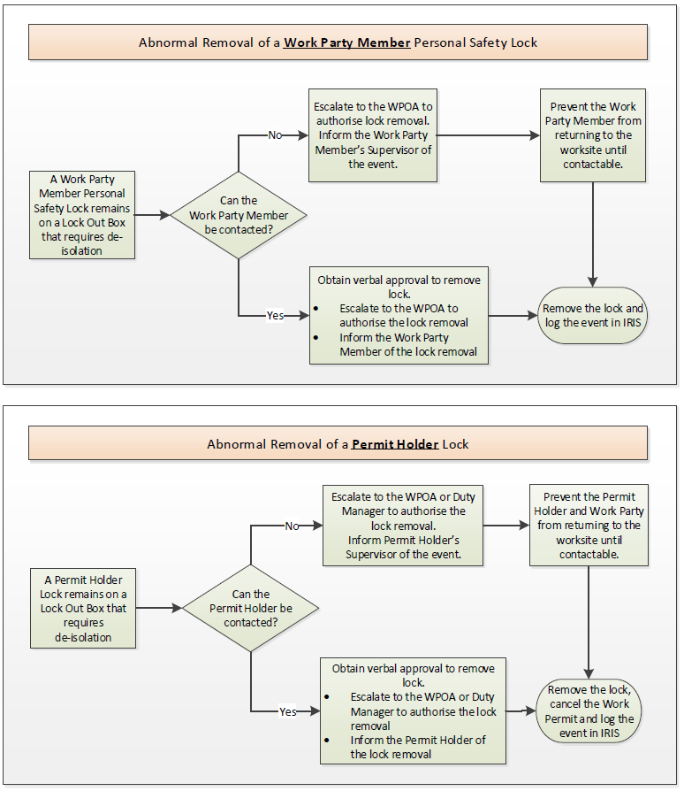
After meeting the criteria of ‘Abnormal Permit Cancellations’ in the Isolation Permit procedure, locks can be removed in line with the following flow charts:

Working when Locks Cannot Be Applied
If isolations do not have the facility to be locked or a lockout device cannot be used/purchased, the following process applies:
Step | Role | Responsibility
1 | Permit Authoriser | Obtain agreement from the Permit Holder to work without the lock.
2 | Permit Holder | Document the controls to be taken in the risk assessment.
3 | Permit Authoriser | Document the precautions to be taken on the Permit.
4 | Permit Authoriser | Attach the ‘Danger - Do Not Operate’ tag.
5 | Permit Authoriser | Advise the Permit Operating Authority of the situation.
6 | Permit Operating Authority | Raise an IRIS event (Hazard) to identify the isolation point(s) which cannot be locked, with actions assigned to modify the asset within six months where practicable.

Key Management
Key management is the responsibility of the relevant area operating authority.

Equipment

Locks
Lock | Description | Example
Isolation Point Lock | Isolation Point Locks are YELLOW and:  - locked onto isolation points such as valves, electrical isolators, etc. to keep equipment in an isolated state  - A set of keyed alike locks is to be used on one Isolation Permit only.  - Keys stored in lock out box | 
Permit Authoriser Lock | Permit Authoriser Locks are BLACK and:  - Are used when the Permit Authoriser has implemented isolations  - the first lock added and last lock removed from a Lock Out Box to prevent returning an asset to service | 
Permit Holder/ Authorised Person Dynamic Isolation | Permit Holder/ Dynamic Isolation locks are BLUE and:  - key kept by the Permit Holder until the permit is surrendered  - locked onto the Lock Out Box until the permit is surrendered.  - Key to be retained by the Permit Holder or authorised person performing a dynamic isolation | 
Personal Safety Locks | Personal Safety Locks are RED and:  - are uniquely keyed and personally identifiable  - must be installed/removed by all workers when working with isolations every day or when leaving the work site to the lock out box  - Key to be retained by the individual | 
Cascade Locks | Cascade Locks are GREEN and:  - applied to Lock Out Boxes to link groups of isolations together or between separate work tasks  - used for managing additional Authorised Permit Holder Isolations | 

Hardware
Hardware | Description | Example
Multi Lock Device | Enables multiple Personal Safety Locks to be fitted to a Lock Out Box or used as a Lock Out Aid. | 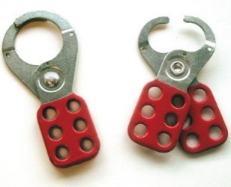
Lock Out Aids | Lock Out Aids are used to lock off isolation points which do not have inbuilt locking points. Lock Out Aids may be permanently installed or portable. | 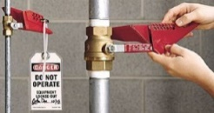
Lock Out Boxes / Isolation Pouches | Lock Out Boxes are used to store:  - a permit and;  - Isolation Point Lock keys, spare Isolation Locks and Cascade Lock keys. | 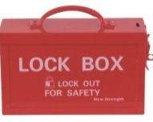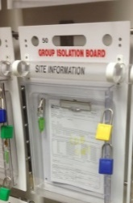

Tags
Tags | Description | Example
Personal Safety | Used to identify owner of a Personal Red Lock
Danger – Do Not Operate | Used for indicating an energy source or isolation point that has had its state changed under a Permit Process or Isolation Standard. | 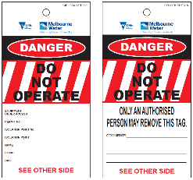
Process Isolation | Used to identify equipment that has had its state changed for operational purposes. This tag shall not be used to identify dangerous equipment or be used in conjunction with a Permit Process. | 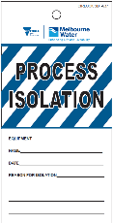
Testing Underway | Used to identify equipment that has had its state changed to facilitate testing as part of the Work Permit Process. This tag shall only be used in relation to the Permit Process and must only replace a ‘Danger - Do Not Operate’ tag. | 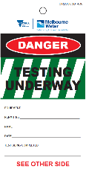
Commissioning in Progress | Used to identify equipment that has not been handed over to Operations staff where the state may change as part of a project handover process. | 
Out of Service | Used to ensure that unsafe plant or equipment is identified prior to repairs or replacement is carried out. | 

References
Links
H&S PRO Isolation Standard and H&S PRO Isolation Permit

Document History
Date | Reviewed/ Actioned By | Version | Action
March 2023 | Senior Safety Manager Service Delivery | 10 | Content review and update
March 2022 | SHEQ Systems Integration Specialist | 9 | Updated formatting and footer.
March 2020 | SHEQ Systems Integration Specialist | 8 | Updated formatting, new template and naming convention.

